DAY 3

SET1 ONLINE GROCERY DELIVERY APPLICATION

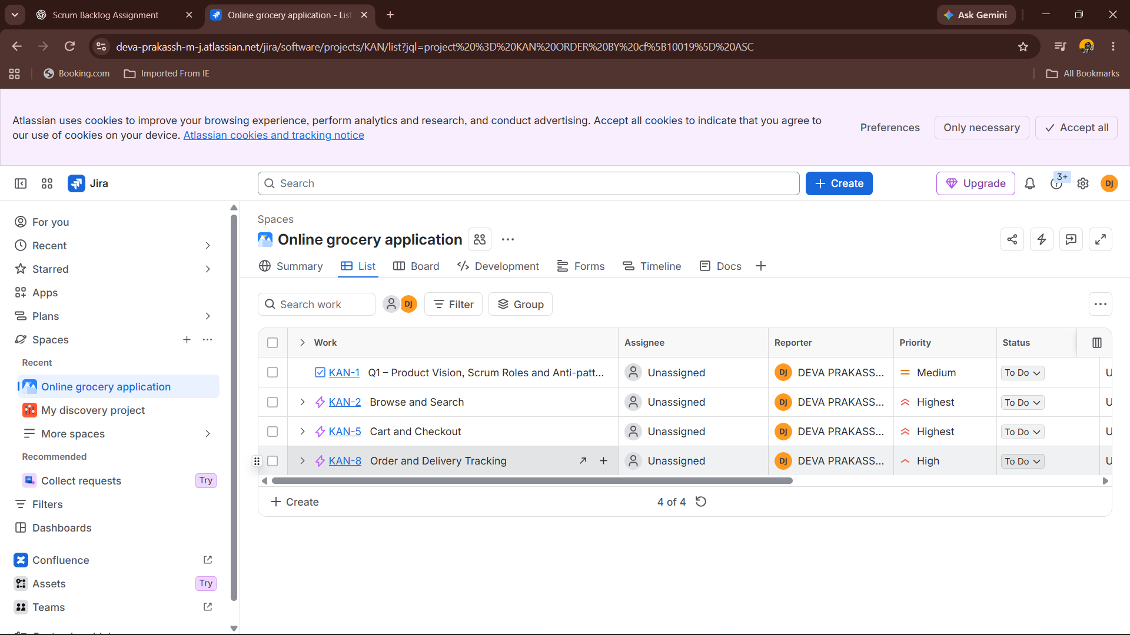
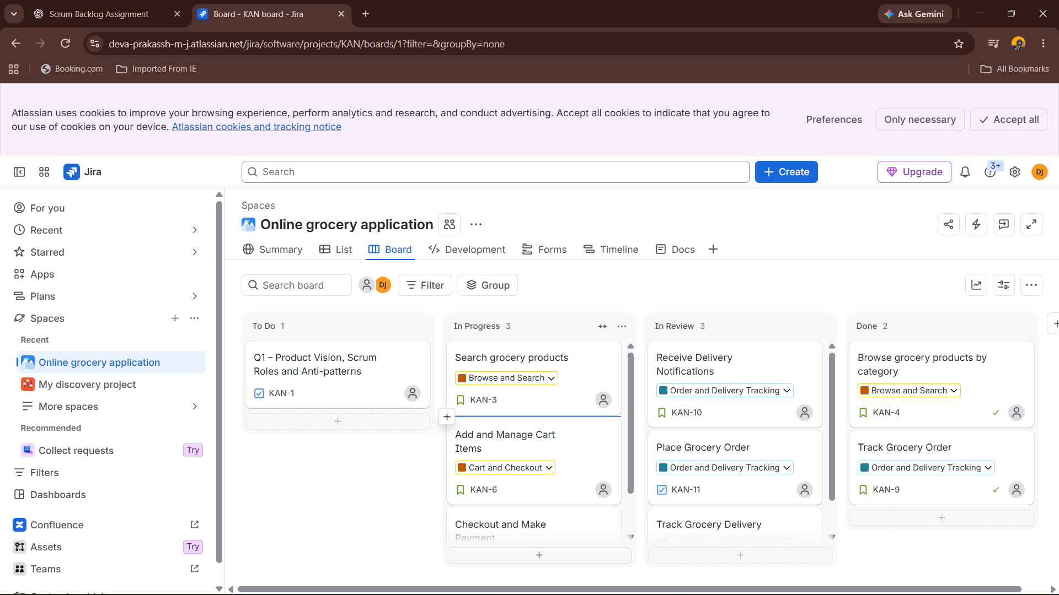

SET 2: INSURANCE CLAIM PROTOCOL

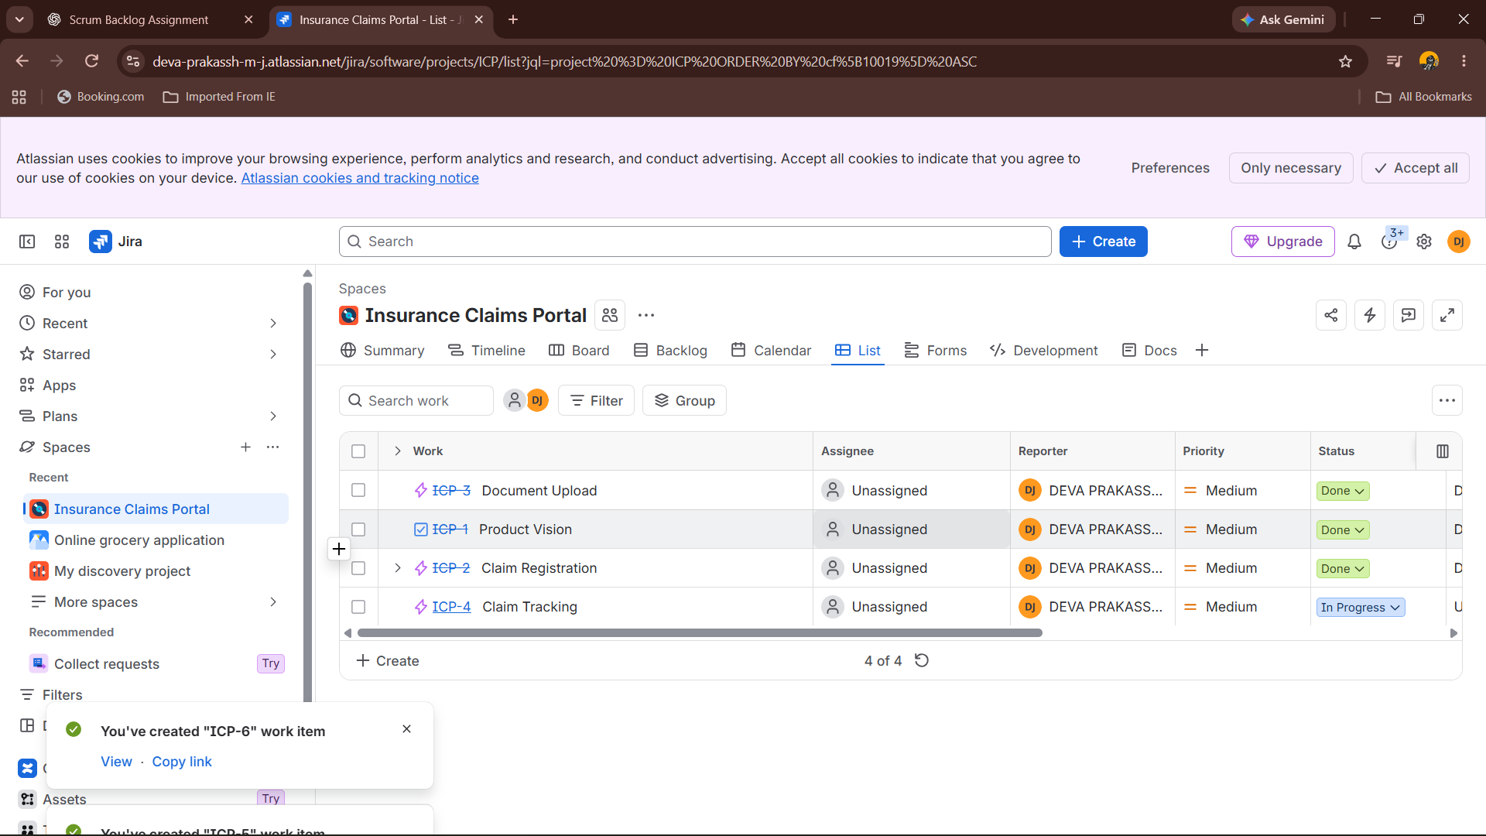

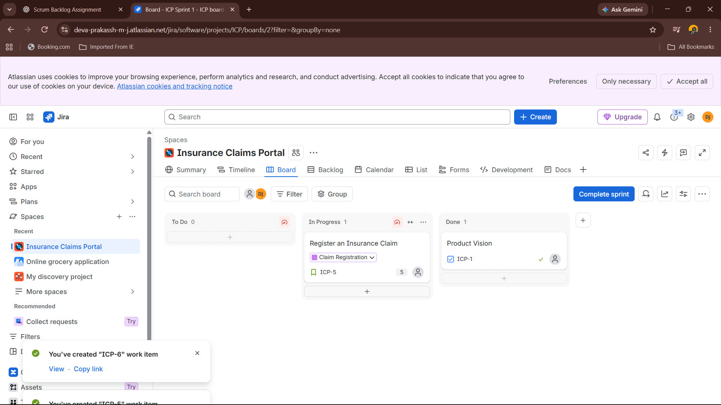

SET3:HOSPITAL BOOKING APPLICATION



